Year 6 LAMDA Results May 2015
40 Year 6 Pupils sat for the London Academy of Music and Dramatic Art (LAMDA). Awarded at Level 1 in Performance (Grade 3) (QCF) Acting Grade 3.
Some students performed 'solo', others in pairs or 'duo'.
Scores between 40 and 59 are considered a Pass, 60 and 79 a Pass with Merit and 80 and 100 a Pass with Distinction.
I am pleased to say we had a 100% pass rate. Two students received a Pass, 26 received a Merit and 12 received a Distinction. These were the best ever results for the Prep School.
Average score was 77% with three students receiving over 90% .
Thank you to Ms Hodgson, Mr Roberts, Zee our LAMDA teacher and the parents in helping and supporting the pupils

READATHON
After the success of the Reading Rocks festival held for a four-week period during spring term, I am pleased to announce the Swaminarayan Prep School raised a total of £1020.86 for Readathon charities. The money is to be distributed towards a number of charities.

As a reward for the school, 20% of the donation - £204.17 - was received in the form of Scholastic book vouchers to be spent by the school.

I will be seeking the assistance of the Prep School Student Council in deciding how the money is to be spent on boosting stocks of popular books in the library.

Well done to all who participated in the Readathon this year!

Donna Roberts
English Coordinator

Below: Winning entries for the Get Caught Reading photo competition, held during the Reading Rocks festival in the spring term. This encouraged pupils to take photos of them reading in unusual places and email them to the school. Winners were decided by a vote from all of the Prep School staff.
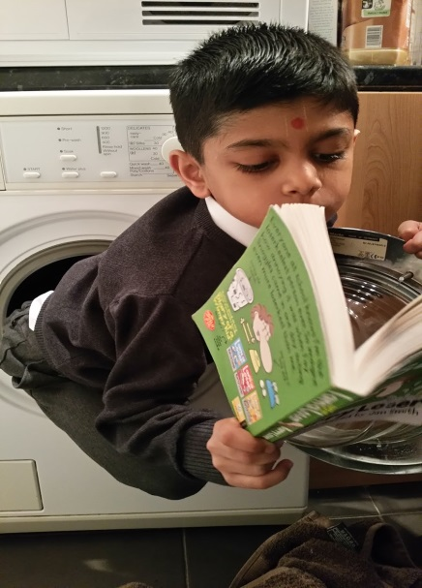
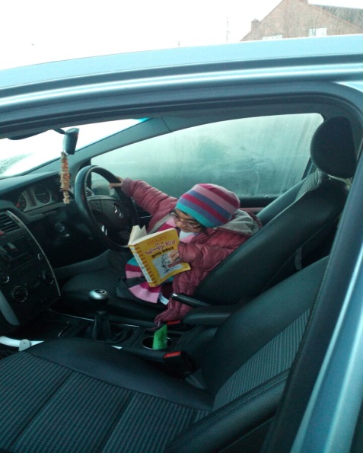
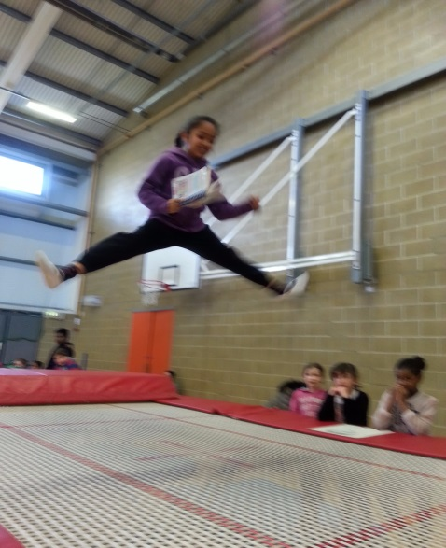
1st: Janani Patel (3D) Equal 2nd: Vachna Gadhia (2N) & Nishaan Patel (2B)

POETRY COMPETITION
I am pleased to announce that the Swaminarayan Prep School has received a generous donation of £2000 from SEGRO, a company who is a leading owner, asset manager and developer of modern warehousing, light industrial and data centre properties, principally concentrated in London's Western Corridor (including the Thames Valley) and in key conurbations in France, Germany and Poland.

The donation was received as winnings for a Poetry Competition entered into by pupils from the Swaminarayan Prep School for the opening of SEGRO’s Origin business park in the Park Royal area. Poems entered with the theme of ‘Our Community - Twenty Years from now’ and the winning poem selected by SEGRO staff was from Sankhya Patel in 6H.

An assembly was held on Wednesday 25th March in which SEGRO staff presented Sankhya with a framed, printed copy of her poem and the school was presented with a cheque. SEGRO staff spoke of the high quality of entries, which are now all buried in a time capsule on site at the Origin pocket park last November.

The donation received on Friday 16 May will be used for the benefit of the students decided in conjunction with the Prep School Student Council.

Donna Roberts
English Coordinator
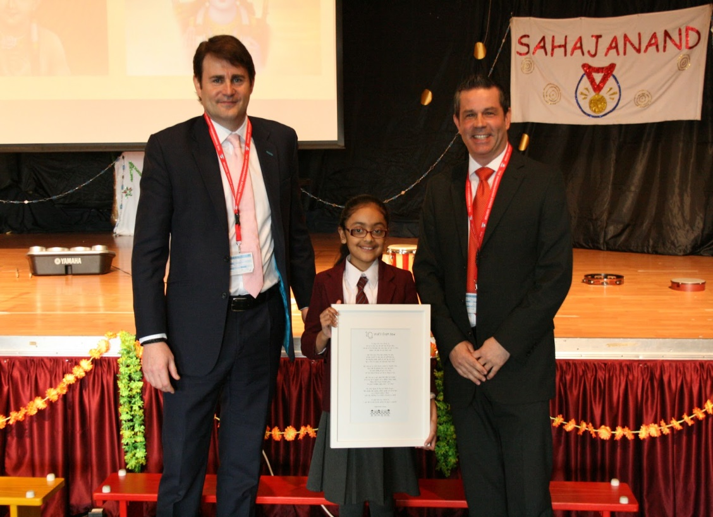
Sankhya Patel with SEGRO representatives

